**COLLEGE OF BUSINESS EDUCATION**



**DEPARTMENT OF MATHEMATICS AND ICT**

**FINAL YEAR PROJECT MANAGEMENT SYSTEM FOR ICT DEPARTMENT AT COLLEGE OF BUSINESS EDUCATION (CBE)**

**FINAL YEAR PROJECT REPORT**

**BACHELOR DEGREE IN INFORMATION TECHNOLOGY.**

**Participant:**

**Shadrack J. Mbala. 03.3443.01.01.2020**

**Adelino A. Ntacho 03.8953.01.01.2020**

Supervisor: Anna Kayanda

Contents

Table of Figures iii

INTRODUCTION 5

1.1 THE HISTORICAL BACKGROUND OF FINAL YEAR PROJECT MANAGEMENT SYSTEM. 5

1.2 PROBLEM STATEMENT 5

1.3 OBJECTIVES 6

1.3.1 General Objective 6

1.3.2 Specific Objectives 6

1.4 PROBLEM JUSTIFICATION 6

1.5 METHODOLOGY 8

1.5.1 Project Constraints 16

1.6 EXPECTED RESULT 17

1.6.1 Expected output 17

1.6.2 Expected Outcome 25

1.7 PROJECT PLAN 25

1.8 CONCLUSION 25

1.9 REFERENCES 26

**User Manual**

**1.** INTRODUCTION 30

**2.** PURPOSE 30

**3.** PREREQUISITE 30

**4.** NEW FYPMS USERS 30

**5.** LOGIN TO FYPMS 30

**6.** USING STUDENT MODULE 31

6.1 Project Feature 32

**7.** Announcement 32

**8.** Project Titles 33

**9.** Log Out 34

**1.** INTRODUCTION 37

**2.** PURPOSE 37

**3.** PREREQUISITE 37

**4.** NEW FYPMS USERS 37

**5.** LOGIN TO FYPMS 37

**6.** USING SUPERVISOR MODULE 38

**6.1** Management Feature 39

**6.1.1** Assess Groups 40

**7.** Announcement 40

**8.** Log Out 1

# Table of Figures

Figure 1 DFD level 0 9

Figure 2 DFD level 1 10

Figure 3 DFD level 2 - Authentication 11

Figure 4 DFD level 2 - User account management 11

Figure 5DFD Level 2 - Group Creation 12

Figure 6 DFD Level 2 - Title Posting 12

Figure 7 DFD Level 2 - Uploading Project Proposal 13

Figure 8 DFD Level 2 - Supervisor marks Assessment 13

Figure 9 DFD Level 2 - Coordinator Generate Report 14

Figure 10 Entity Relationship Diagram (ERD) 14

Figure 11 Use case Diagram 15

Figure 12 Coordinator Home Page - Profile 17

Figure 13 Group Size Limit Creation For Academic Year 18

Figure 14 Group Importation 19

Figure 15 Supervisor Import 20

Figure 16 Final Report 20

Figure 17 Group Creation 21

Figure 18 Group Details Review 22

Figure 19Students view Assigned Supervisr 23

Figure 20 Assigned Groups Details 24

Figure 21 Marks Assessment by Supervisor 24

# INTRODUCTION

# THE HISTORICAL BACKGROUND OF FINAL YEAR PROJECT MANAGEMENT SYSTEM.

Final Year Project Management System, is a project which intends to improve activities concerning management of Students Final Year Projects by the ICT Department at College of Business Education Dar-es-salaam (CBE).

Currently Final year Projects are undertaken through manual works for instance, student project groups are created and collected by class representative though papers then the papers are to be submitted to the project coordinator. Incase of any changes on the member of any group, the coordinator has to redo the whole task of creating an updated student’s group table. Activities associated with the whole task of creating, update and submitting groups to the coordinator is a very tiresome task.

ICT department use file systems such as Microsoft office (Microsoft Excel) to manipulate data concerning Final Year Projects. File systems does not provide a clear data integrity as to the fact that any person access the data and can change the data without authoritative checks. Due to lack of data integrity might lead to poor organization of data and effective communication in the management scope. Also, in case of file or system corrupt the whole data will be lost.

The system will allow students to post their project titles and their project proposals as soon as their project groups’ accounts are created by the coordinator and be able to submit them directly to the system, thereby a project coordinator can access and review data without involving the class representative. Through the system, Concurrent data access by multiple users is possible without distracting the integrity of the data. Data manipulation can be achieved easily and will be done by authorized users.

The goal of the System is to enable good organization of data, data integrity and proper coordination of student, supervisors and Project Coordinator for the purpose of simplifying activities done during the management of the Final Year Projects.

The project will take an approximate duration of 2 months to be implemented and tested.

# 1.2 PROBLEM STATEMENT

Currently, management of Final Year Project of Student by the ICT department is based on papers and file systems. Example students group registration and their project titles are done through papers. The means of storage is vulnerable to data loss, data access is a challenge in terms of misplacement of papers or device with the file system, also manipulation of data comes a challenge when data are kept in papers (edit, delete or updates are impossible in papers).

So, under these circumstances, the system intends to fill the observed problems encountered in managing and organization of the Final Year Project Management System.

# 1.3 OBJECTIVES

## 1.3.1 General Objective

The aim of this project is to develop a Final Year Project Management System. Additionally, the Final Year Project Management System it is a web-based system which will enable students to post their final year projects titles and project proposals as soon as their project groups’ accounts are created by the coordinator and be able to submit them directly to the system. Moreover, supervisor to assess students based on their presentations, coordinator to manage all students and supervisors also to have all the required reports concerning final year student’s projects.

## 1.3.2 Specific Objectives

* To collect all requirements from users (coordinator, supervisors, students).
* To design the system.
* To develop the system.
* Test and validate the system.

# 1.4 PROBLEM JUSTIFICATION

The Final Year Project Management System is necessary as it will improve and simplify the work flow concerning the management of Final Year Project.

The system will have 3 users namely, Project Coordinator, Supervisor and Student.

The system will work in the following manner:

* Coordinator will have his or her account for the management activities related to Final Year Project.

* Coordinator can set a limit number of participants of final year project groups with respect to a particular academic year that project Management is being undertaken.
* Coordinator will prepare a list of Final Year project groups with required student’s details in an excel document and then the document can be imported successfully into the system to allow the creation of the student groups’ accounts.
* Coordinator will prepare a list of Final Year project Supervisors with required supervisor’s details in an excel document and then the document can be imported successfully into the system to allow the creation of the supervisor ’s accounts.
* Students will create their groups through the system and finally their groups will be saved.
* student will be able to post their project titles into the system and also view if their title is accepted or not.
* Students can review formulated group
* Students can view assigned project supervisor
* Supervisor will be able to view assigned student groups for supervision, assess students based on their project presentations and view reports.
* Coordinator will be able to create, update and delete users and provide roles, view students’ project groups and their titles, assign supervisors to student groups, assess student based on their project presentations and view different reports.

The chances that the project could open is that, the project could be used to manage Final Year student Project within and outside the campus.

# 1.5 METHODOLOGY

The methodology to be used on the proposed system is **prototype model.**

A Rapid Throwaway Prototype model was used whereby the prototype was developed based on the preliminary requirements which was even revised through client’s feedback so, a number of prototypes were discarded depending on the client or user feedback until the final product was obtained.

Why prototype?

* The user is fully involved in the software product making even before the software product is fully implemented.
* This involvement gives user pure understandability of software product being developed.
* Gives developer higher chance of developing a software product that meets user requirements.

The following were the phases of a throwaway prototype model:

1. **Identification of Requirements**: All the initial requirements were gathered from different users including coordinator, students and Supervisors.

Requirement were collected from the following members

* Project Coordinator (Anna Kayanda)

1. Coordinator should be able to add student groups into the system
2. Coordinator should be able to assign supervisors to the respective student project groups.
3. Coordinator should be able to view different kinds of report including project phase presentation marks.

* Project Supervisors (Baraka Mwasampeta, Anna Kayanda)

1. Project Supervisor should be able to view students project groups that are assigned to him or her by the coordinator.
2. Project Supervisor should be able to assess project groups during project phase presentation.

* Students. (Macmillan, Edwin, Joseph Jonathan)

1. Student should be able to create groups in the system.
2. Students should be able to upload their project Titles together with their Project Proposals in the System.
3. Student should be able to view their accepted or rejected Project Titles and Proposals.
4. Student should be able to view their Final Report of the Project.
5. **Planning:** All the designs including the Entity Relation Diagrams, Data Flow Diagrams and Use cases were obtained reflecting the Final Year Project Management System.

Figure DFD level 0

Figure DFD level 1

A data Flow Data Diagram Level 1

Figure DFD level 2 - Authentication

Figure DFD level 2 - User account management

A data Flow Diagram Level 2.2

Figure DFD Level 2 - Group Creation

Figure DFD Level 2 - Title Posting

Figure DFD Level 2 - Uploading Project Proposal

Figure DFD Level 2 - Supervisor marks Assessment

Figure DFD Level 2 - Coordinator Generate Report

Figure Entity Relationship Diagram (ERD)

Figure Use case Diagram

1. **Prototype:** A prototype was developed and it is usually the working model of the entire system. The Prototype was introduced to the end users who will test and evaluate them.
2. **Prototype Enhancement:** The data feedback from the user made the prototype to undergo further refining until it reached the point where the users are satisfied.
3. **Finalization:** The Final Product was obtained.

The system will be implemented module wise in an interval of 1 week per module. A complete module or prototype will be reviewed by mentioned users to provide modification feedback if necessary. If modification is needed then, it will be taken into account.

## 1.5.1 Project Constraints

The following are the constraints for the project

* The user should provide requirements full and complete to his or her ability.
* There should be maximum cooperation between users and Project Manager.
* An appointment between user and the project Manager should be Consistent.

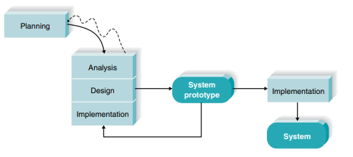

# 1.6 EXPECTED RESULT

## 1.6.1 Expected output

The Expected output from this project is the Final Year Project Management System.

The system provides the following functionalities depending on the user.

* Coordinator will have account for the management activities related to Final Year Project.

Figure Coordinator Home Page - Profile

* Coordinator can set a limit number of participants of final year project groups with respect to a particular academic year that project Management is being undertaken.

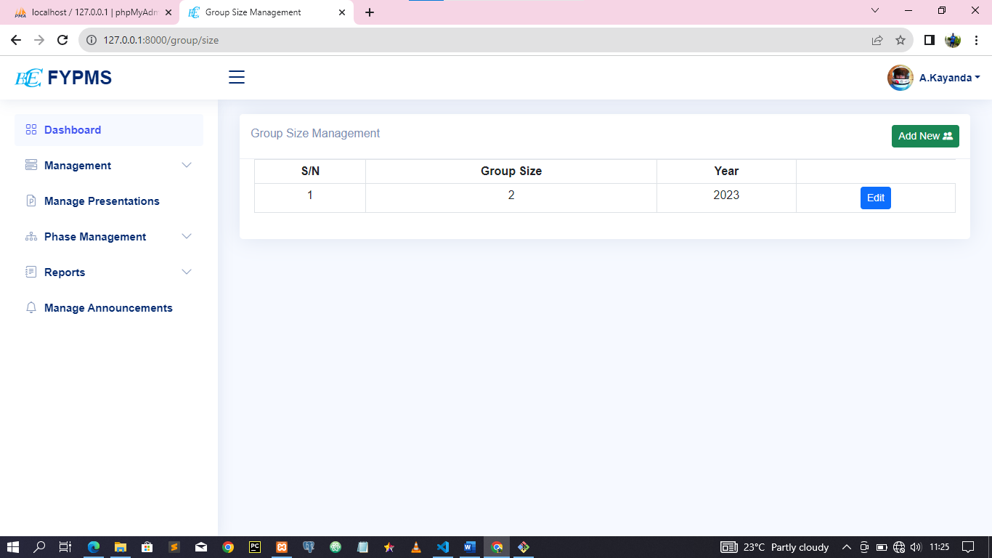

Figure Group Size Limit Creation For Academic Year

* Coordinator will prepare a list of Final Year project groups with required student’s details in an excel document and then the document can be imported successfully into the system to allow the creation of the student groups’ accounts.

Figure Group Importation

* Coordinator will prepare a list of Final Year project Supervisors with required supervisor’s details in an excel document and then the document can be imported successfully into the system to allow the creation of the supervisor ’s accounts.

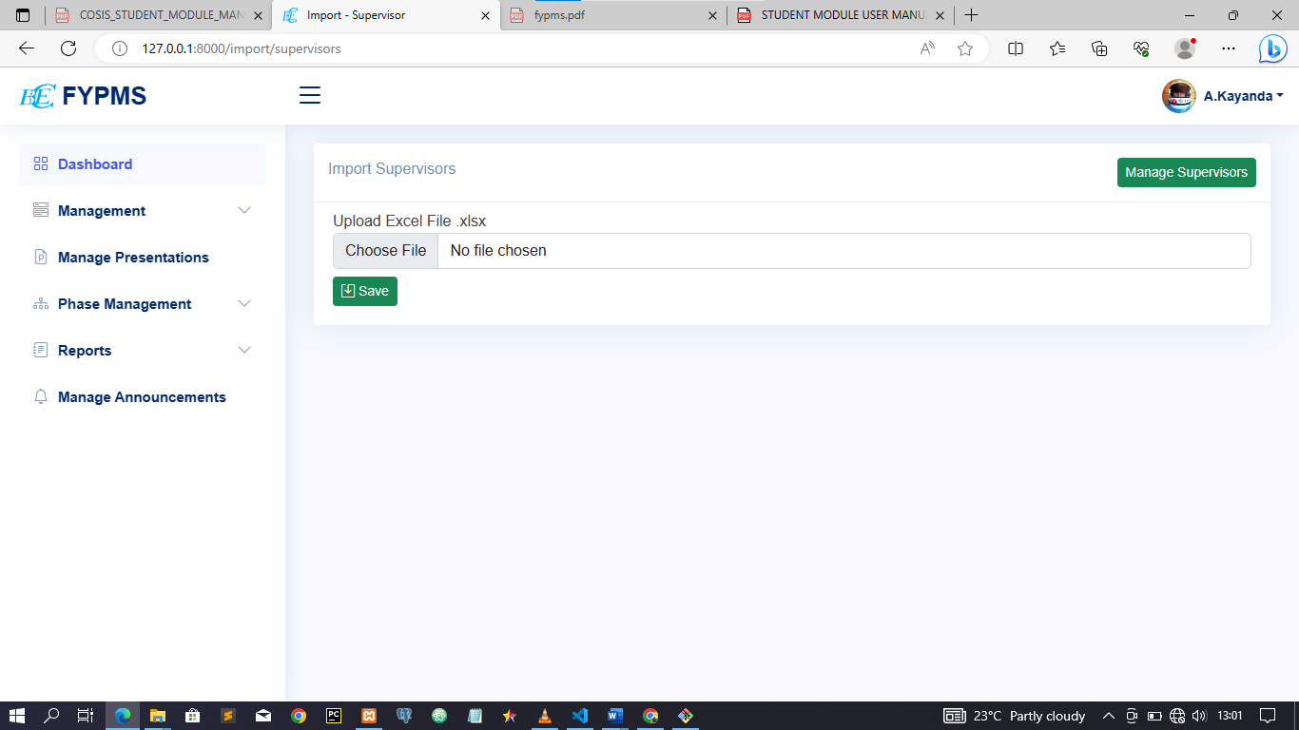

Figure Supervisor Import

* Coordinator can view Final Report of the Final Year Project Management

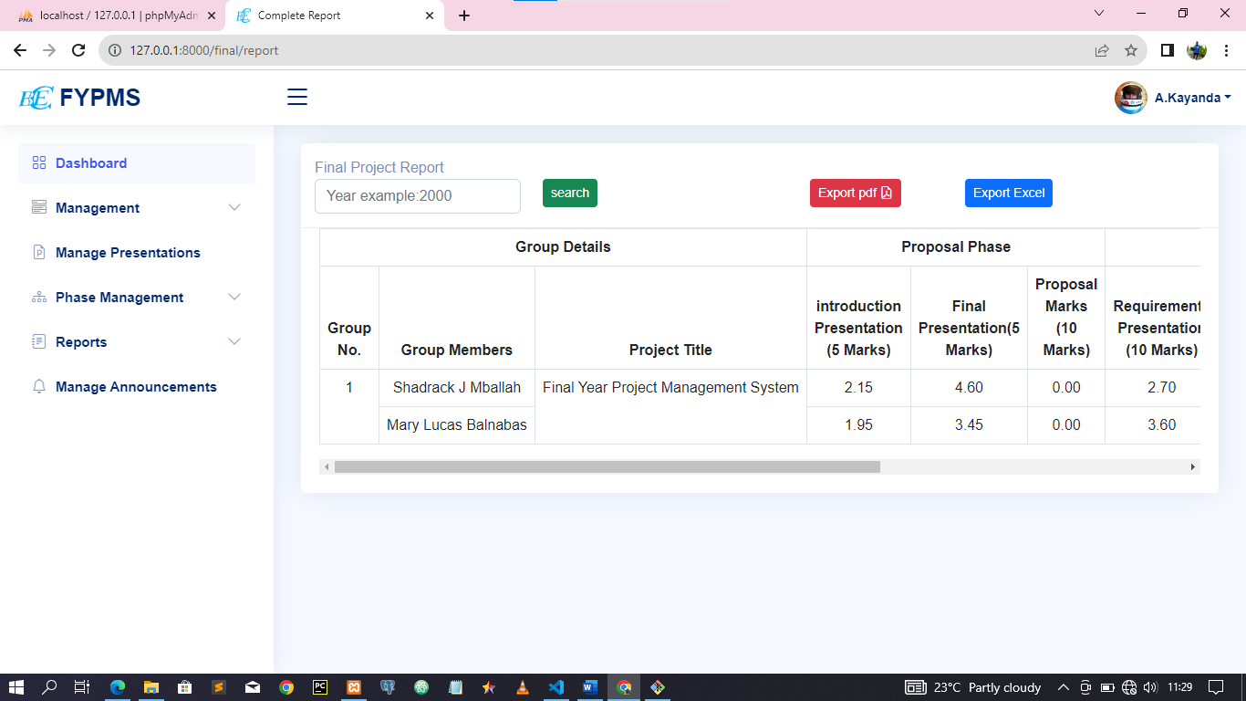

Figure Final Report

* Students will create their groups through the system and finally their groups will be available in the system.

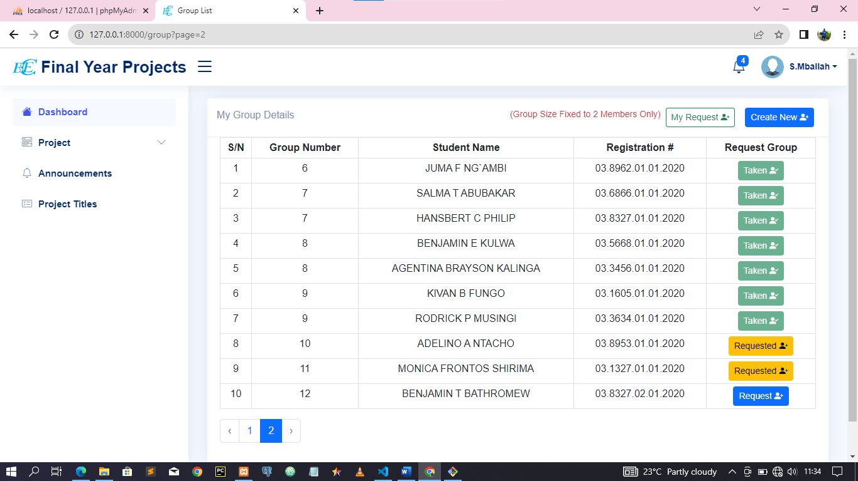

Figure Group Creation

* student will be able to post their project titles into the system and also view

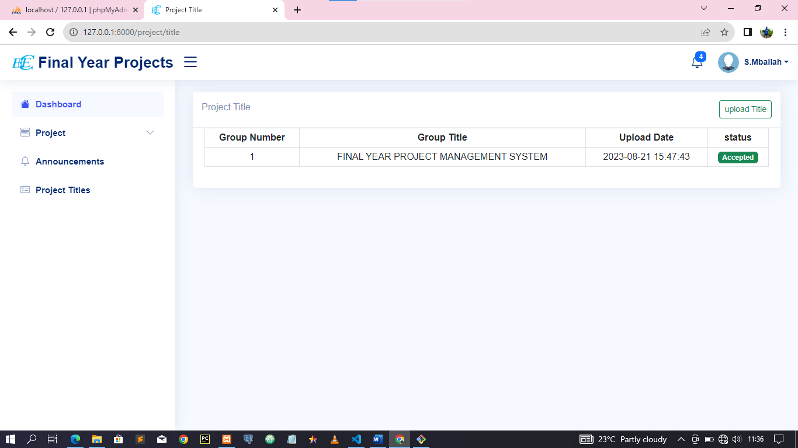

* Students can review formulated group

Figure Group Details Review

* Students can view assigned project supervisor

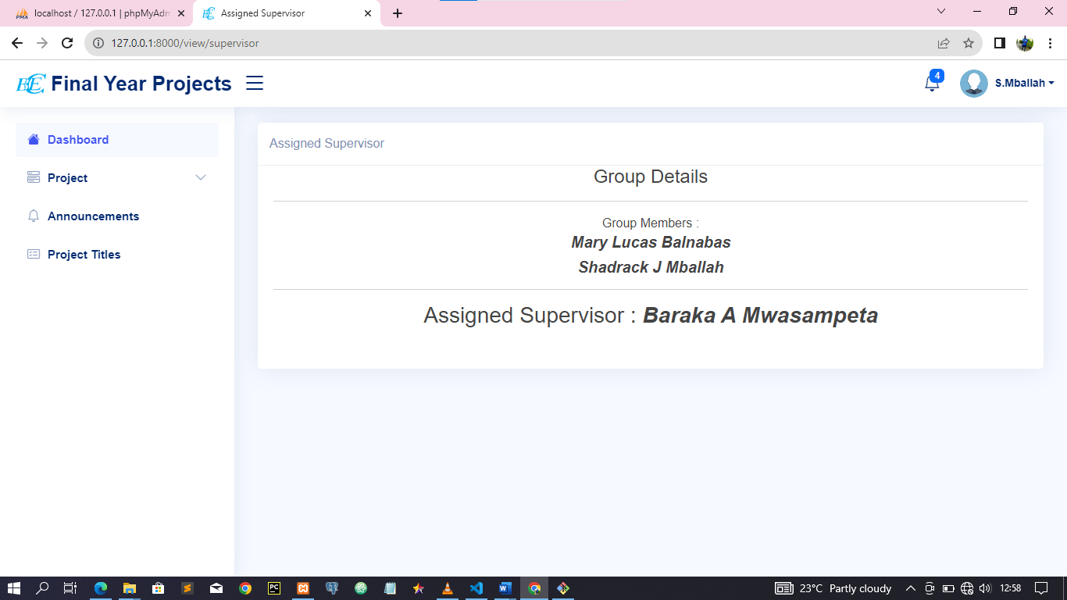

Figure Students view Assigned Supervisr

* Supervisor will be able to view assigned student groups for supervision, assess students based on their project presentations and view reports.

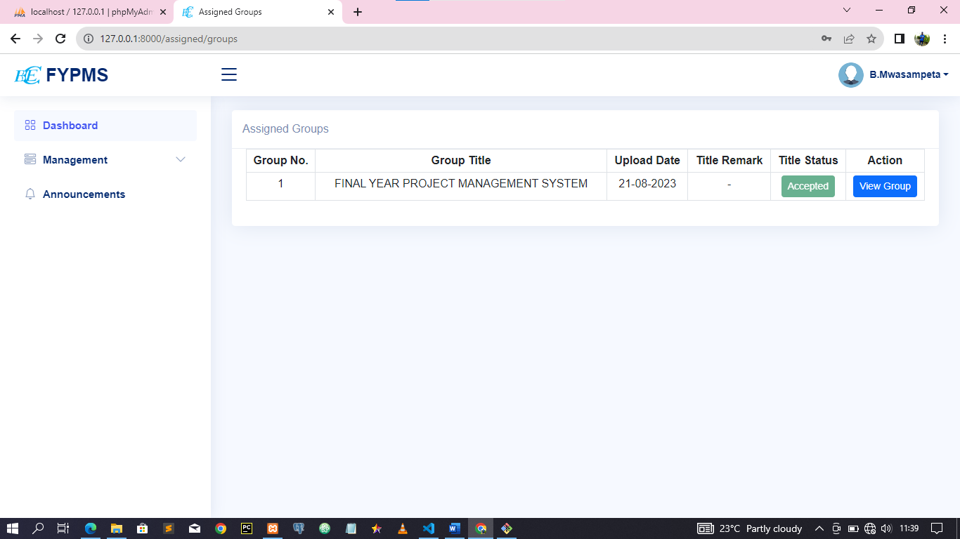

Figure Assigned Groups Details

* Supervisor can assess project group depending on the phase

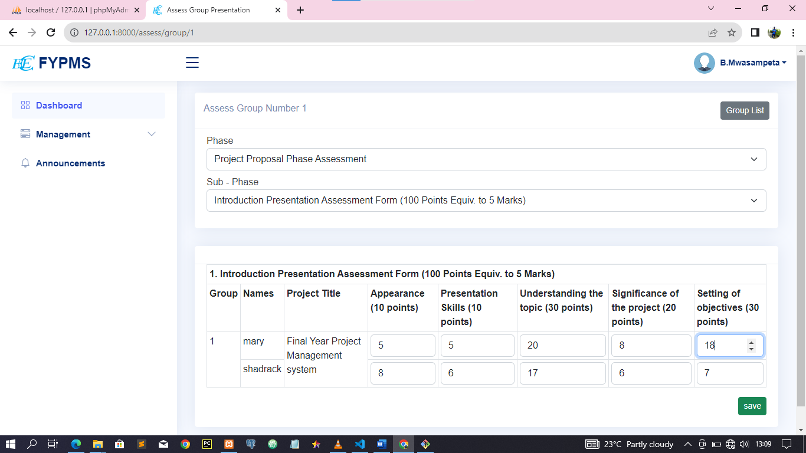

Figure Marks Assessment by Supervisor

## 1.6.2 Expected Outcome

* Students will create their groups and post their project titles in the system without using papers

# 1.7 PROJECT PLAN

Table Project Plan

|  |  |  |  |  |  |  |
| --- | --- | --- | --- | --- | --- | --- |
| SN | Task | Days | Start Date | Estimate Completion Date | Deliverables | Responsible |
| 1 | Requirements gathering | 5 | 31/03/2023 | 4/04/2023 | Functional and Non-functional Requirements | Adelino  &  Shadrack |
| 2 | Requirements analysis | 10 | 5/04/2023 | 14/04/2023 | Data Flow Diagrams.  Entity Relationship Diagram | Adelino  &  Shadrack |
| 3 | Design of the Software | 8 | 15/04/2023 | 22/04/2023 | System specification (Interface design, database design…etc.) | Adelino  &  Shadrack |
| 4 | System Development | 30 | 24/05/2023 | 24/05/2023 | Software product | Adelino  &  Shadrack |
| 5 | System test and validation | 4 | 25/05/2023 | 28/05/2023 |  | Adelino  &  Shadrack |

# 1.8 CONCLUSION

Therefore, The Final Year Project Management system intends to help ICT Department at CBE by improving way of management by allowing coordinator to manage both students and supervisors by registering them to a system, assigning supervisor to student’s groups, review and generate assessment reports of the student’s presentations. To a supervisor the system will provide easy way to supervise their assigned groups of students also to assess students based on their presentations.

Students will be able to create their groups and post their final year project Titles, review their assessment reports and also to see their final panel comments and results. Lastly the system will create easiness in data manipulation also reducing the different data lost vulnerabilities, as all data will be stored in a well secured database, its access is through the secured HTTP protocol so as to ensure non-authorized user should never access our system data.

# 1.9 REFERENCES

[www.software-development.com.au](http://www.software-development.com.au)

[www.irjmets.com](http://www.irjmets.com)

APPENDIX

STUDENT MODULE USER MANUAL

COLLEGE OF BUSINESS EDUCATION



**FYPMS STUDENT MODULE USER MANUAL**

**2023**

Contents

1. INTRODUCTION **4**
2. PURPOSE **4**
3. PREREQUISITE **4**
4. NEW FYPMS USERS **4**
5. LOGIN TO FYPMS **4**
6. USING STUDENT MODULE **5**
   1. Project Feature **6**
7. Announcement **6**
8. Project Titles **7**
9. Log Out **8**

LIST OF FIGURES

Figure 1 FYPMS Login Page 5

Figure 2 Student Features 5

Figure 3 Project features 6

Figure 4 Announcement feature 7

Figure 5 Project Title Features 7

# INTRODUCTION

The initiative aims at creating a platform on which students can, for example Create Group by either creating a new group, then wait for other students to join the group or a student can request to join to an existing project group. Also, student can post their project title, then have ability to see status of project title if accepted if not they are able to re-post their title again. Student can also upload their project proposal document to the system in format of word document only (docx).

The Final Year Project Management System (FYPMS) is a web‐based application developed for management of students’ academic in case of their final year project under department of ICT at CBE (Dar Es Salaam Campus). FYPMS provides all necessary functionalities for tracking and managing both Student and Supervisor at once and all their management activities. It is a one stop centre for students to perform their Final Year Project Related activities and retrieve data related to their activities.

# PURPOSE

The purpose of this user manual is to provide detailed instructions and procedures for students to navigate and understand how the student module works based on predefined student roles in FYPMS. This will improve help them to use the system efficiently.

# PREREQUISITE

For a student to be able to use the student module in FYPMS, the following requirements must be fulfilled:

* 1. Must be a registered student
  2. Must have valid username and password
  3. Must be connected to the internet

# NEW FYPMS USERS

New students should use their registration numbers as “Username.” And Default password will be sent to their email After being registered at the coordinator’s office, a student will be able to use the emailed password. He/she will use the registration number as his/her username and password to login to the system. After a success login a system will prompt you to change your password. The new password must contain not less than eight (8) characters in which capital letters, small letters, special symbol and numbers must be used. 5.

# LOGIN TO FYPMS

To access and login to FYPMS, visit CBE website (<http://domain.example/login>) and click FYPMS link which will take you to the FYPMS login page. Enter correct and valid username and password to use the FYPMS. You can also access FYPMS by directly typing the FYPMS <http://domain.example/login>as shown in Figure 1. Provided that your device is connected to the internet, the browser will direct you to the FYPMS login page

*Figure 1 FYPMS Login Page*

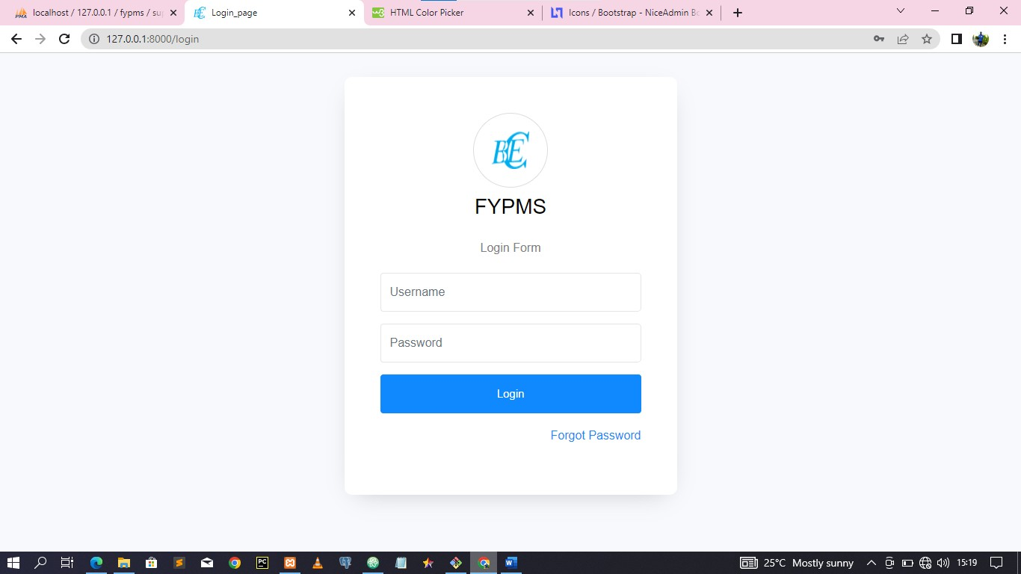

# USING STUDENT MODULE

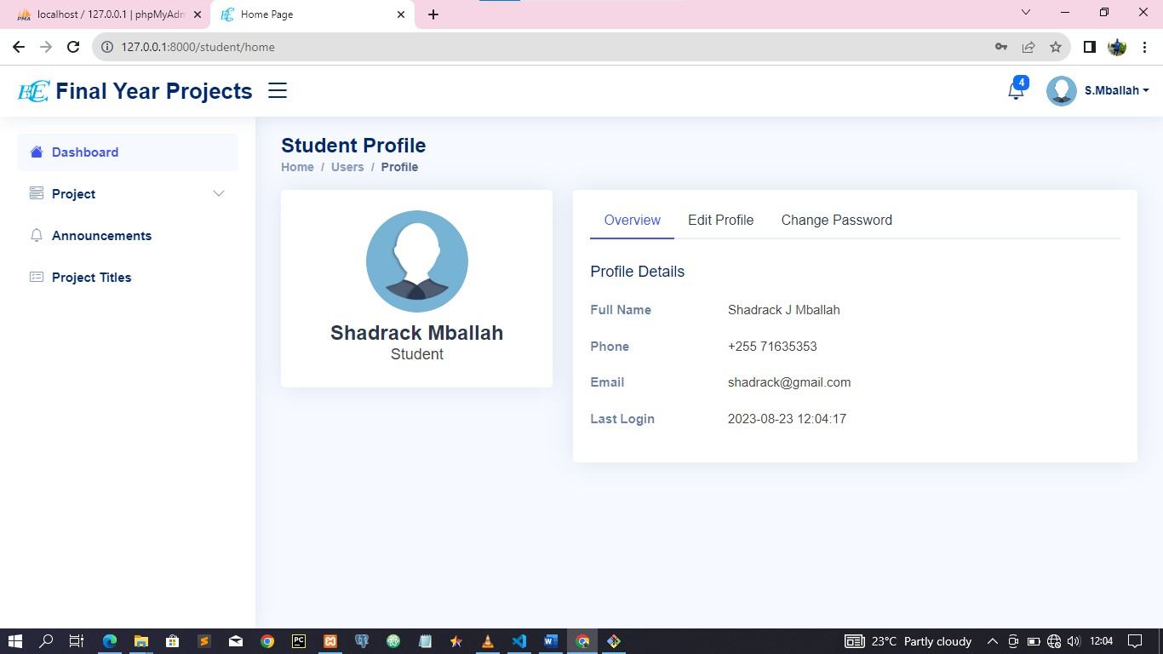This is a module for students in which all FYPMS features related to students’ operations can be accessed. These include Group Creation, Request to join to a group, views group information, view request status of posted title, group request and proposals, view Assigned Group Supervisor, View Announcements, view previous academic years done project titles, edit Profile and change password. Features in this module are user friendly and easy to understand when used along with this manual. Figure 2 shows all features for students’ FYPMS operations

*Figure 2 Student Features*

# 6.1 Project Feature

This feature comprises of “Create Group”, “My Group” and “Project Title”, “Project Proposals”,” Supervisors”. Through this feature you can access your profile to view your details and status. If you wish to update your details such as profile picture or password, you can do it in your right-hand tabs by selecting the desired tab. If you update any information in your system, remember to save changes. Figure 3 shows features comprised in the Project Feature.

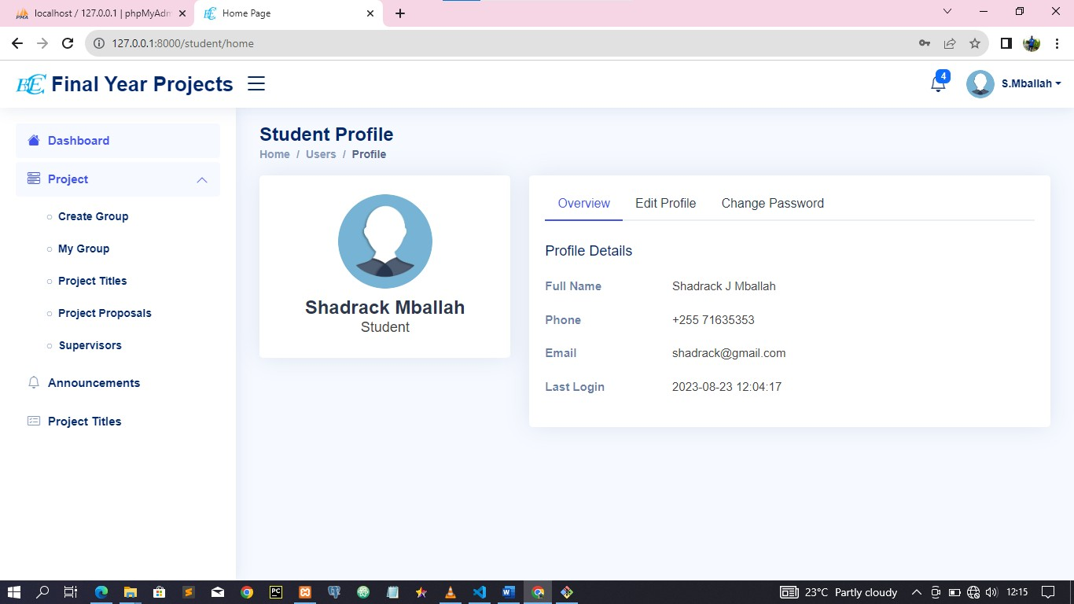

*Figure 3 Project features*

# Announcement

This feature allows you to view Announcement published to the system by project coordinator it shows the announcement with the time announcement was published.

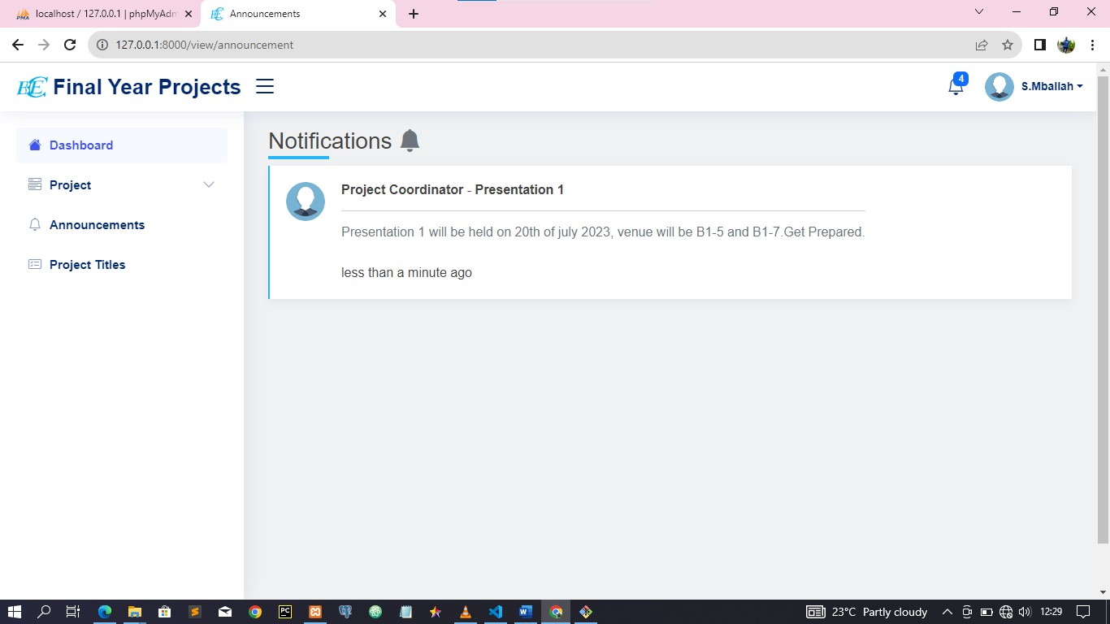

*Figure 4 Announcement feature*

# Project Titles

This feature allows you to view published titles that were accepted and done in previous Academic Years including the current year accepted Project Titles.

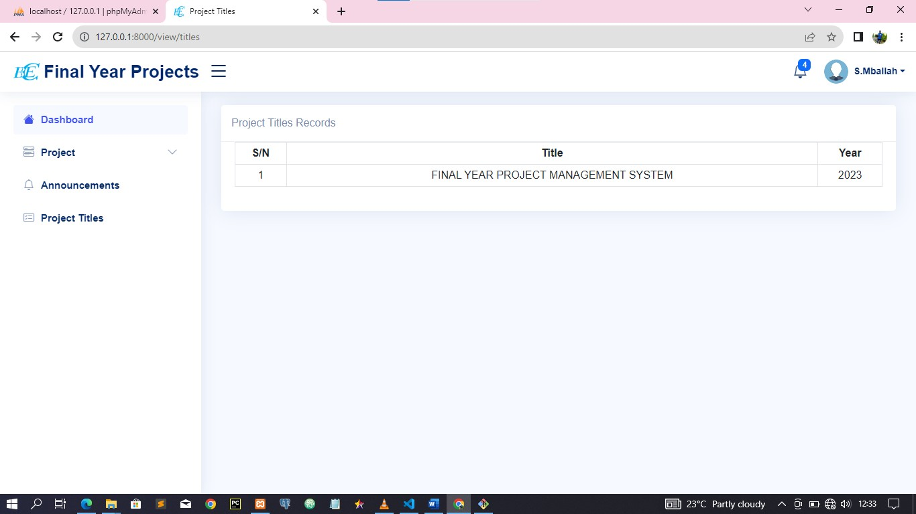

*Figure 5 Project Title Features*

# Log Out

The last feature on the student module panel is log-out. Once you have finished working in FYPMS, you will use the “Log Out” feature to sign out from the system. This will end your current FYPMS session, and you will be required to start all over again in section 5, if you wish to continue using the FYPMS.

SUPERVISOR MODULE USER MANUAL

Contents

1. INTRODUCTION **4**
2. PURPOSE **4**
3. PREREQUISITE **4**
4. NEW FYPMS USERS **4**
5. LOGIN TO FYPMS **4**
6. USING SUPERVISOR MODULE **5**
   1. Management Feature **6**
      1. Assess Groups **7**
7. Announcement **7**
8. Log Out **8**

LIST OF FIGURES

Figure 1 FYPMS Login Page 5

Figure 2 Supervisor Features 6

Figure 3 Management features 6

Figure 4 assess group 7

Figure 5 Announcement feature 7

# INTRODUCTION

The initiative aims at creating a platform on which supervisor can, for example

View assigned groups, view group members and assess groups according to their project presentations.

The Final Year Project Management System (FYPMS) is a web‐based application developed for management of students’ academic in case of their final year project under department of ICT at CBE (Dar Es Salaam Campus). FYPMS provides all necessary functionalities for tracking and managing both Student and Supervisor at once and all their management activities. It is a one stop centre for students to perform their Final Year Project Related activities and retrieve data related to their activities.

# PURPOSE

The purpose of this user manual is to provide detailed instructions and procedures for students to navigate and understand how the student module works based on predefined student roles in FYPMS. This will improve help them to use the system efficiently.

# PREREQUISITE

For a student to be able to use the student module in FYPMS, the following requirements must be fulfilled:

* 1. Must be a registered student
  2. Must have valid username and password
  3. Must be connected to the internet

# NEW FYPMS USERS

New supervisor should use their email as “Username.” And Default password will be sent to their email After being registered at the coordinator’s office, a supervisor will be able to use the emailed password. He/she will use the email address as his/her username and password to login to the system. After a success login a system will prompt you to change your password. The new password must contain not less than eight (8) characters in which capital letters, small letters, special symbol and numbers must be used. 5.

# LOGIN TO FYPMS

To access and login to FYPMS, visit CBE website (<http://domain.example/login>) and click FYPMS link which will take you to the FYPMS login page. Enter correct and valid username and password to use the FYPMS. You can also access FYPMS by directly typing the FYPMS <http://domain.example/login>as shown in Figure 1. Provided that your device is connected to the internet, the browser will direct you to the FYPMS login page

*Figure 1 FYPMS Login Page*



# USING SUPERVISOR MODULE

This is a module for supervisor in which all FYPMS features related to supervisors’ operations can be accessed. These include, Assigned Groups, Assess Groups and Announcements, Edit Profile and Change password. Features in this module are user friendly and easy to understand when used along with this manual. Figure 2 shows all features for supervisor FYPMS operations.

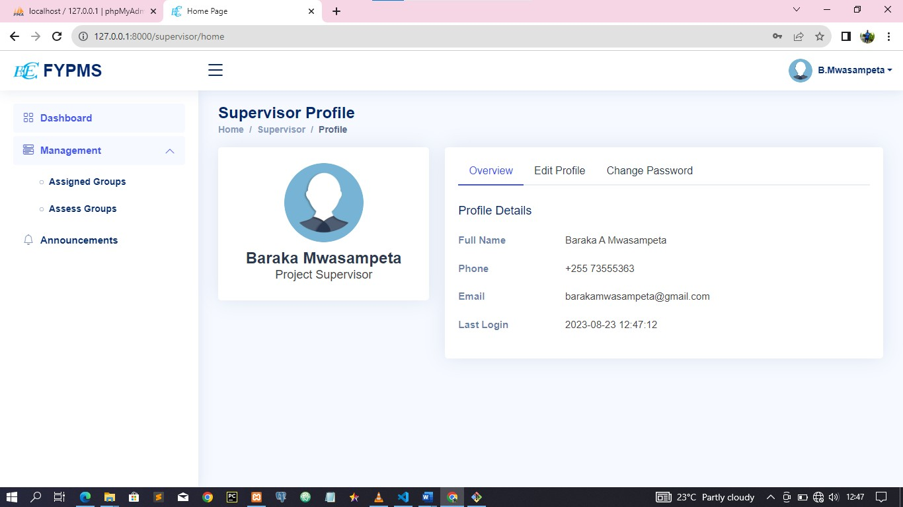

*Figure 2 Supervisor Features*

# Management Feature

This feature comprises of “Assigned Groups” and “Assess Groups”.Through this feature you can access your profile to view your details and status. If you wish to update your details such as profile picture or password, you can do it in your right-hand tabs by selecting the desired tab. If you update any information in your system, remember to save changes. Figure 3 shows features comprised in the Project Feature.



*Figure 3 Management features*

# Assess Groups

Here you assess each group by providing marks to each student in a group separately. Remember to save the form of assessment and ensure you get the assessment was successfully message after submit the form.

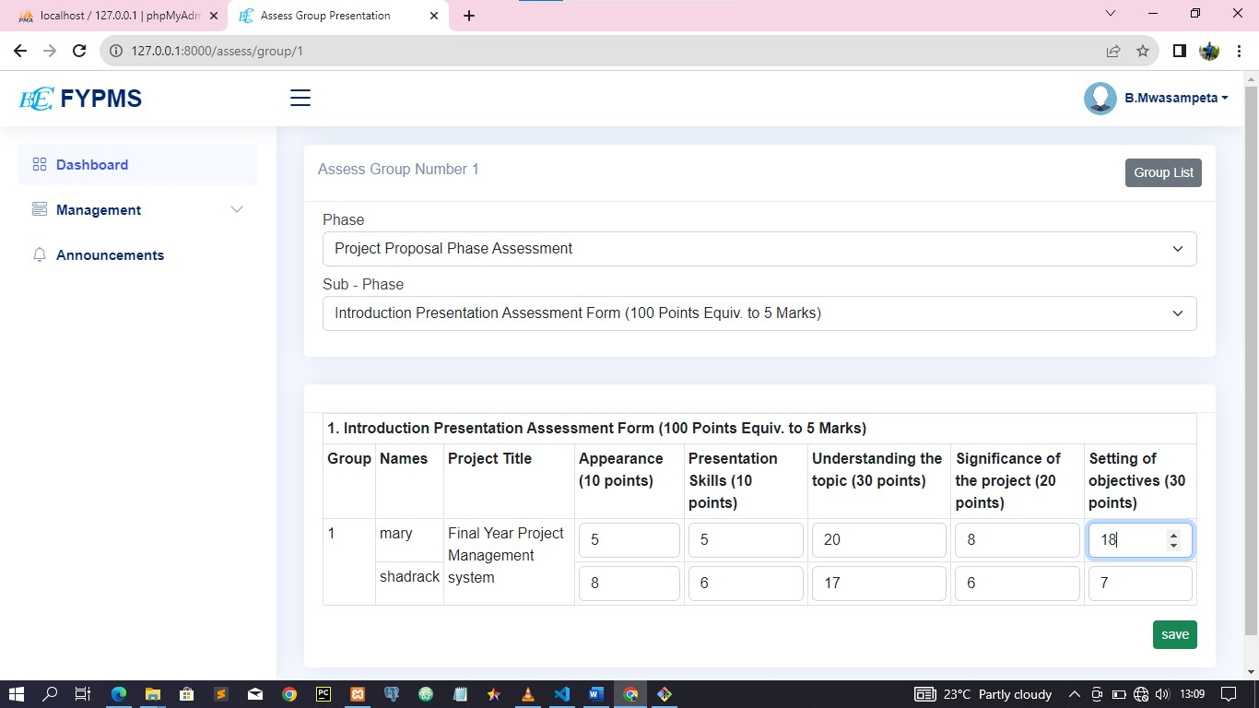

*Figure 4 assess group*

# Announcement

This feature allows you to view Announcement published to the system by project coordinator it shows the announcement with the time announcement was published.

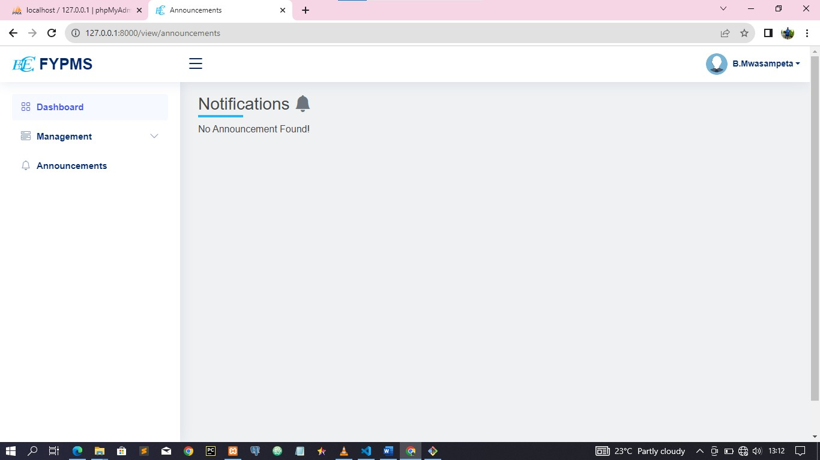

*Figure 5 Announcement feature*

# Log Out

The last feature on the student module panel is log-out. Once you have finished working in FYPMS, you will use the “Log Out” feature to sign out from the system. This will end your current FYPMS session, and you will be required to start all over again in section 5, if you wish to continue using the FYPMS.